# Lab 7

## **Construct an ER Diagram of Hospital Management system.**

## **Objective:**

* To understand the component of ER diagrams.
* To learn how ER diagram is represented using different entities and attributes.

## **Theory:**

An Entity Relationship Diagram (ER Diagram) pictorially explains the relationship between entities to be stored in a database. Fundamentally, the ER Diagram is a structural design of the database. It acts as a framework created with specialized symbols for the purpose of defining the relationship between the database entities. ER diagram is created based on three principal components: entities, attributes, and relationships.

The ER diagram for the Hospital Management System outlines the key components and relationships within the system. It includes entities like Hospital, Patient, Patient Medical Record, Doctors, and Services. Hospitals are characterized by their unique IDs, names, locations, and contact details, and they employ multiple doctors. Patients are identified by unique IDs and have personal information, and they can be associated with multiple medical records for different treatments. Doctors, with their specific IDs and specialization areas, can treat multiple patients. Additionally, the services provided by hospitals are listed, each with its own unique ID, name, description, and cost.

## **Output:**

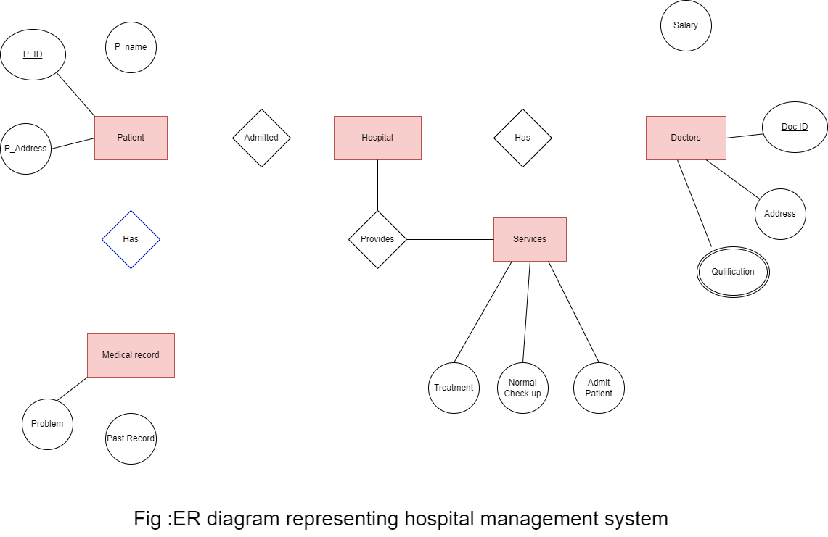

## **Conclusion:**

The ER diagram for hospital management system is constructed. The ER diagram illustrates how different entities (Hospital, Patient, Patient Medical Record, Doctors, and Services) are related to each other in a Hospital Management System.